A discrete Fourier transform (DFT) technique to synthesize the photo-acoustic spectrometer (PAS) speaker test signal.

D C Law 08APR2009

Introduction

It is necessary to periodically measure the resonant frequency of the PAS cells. In an earlier version of the instrument, this was accomplished by generating a sinusoidal driving signal for the piezoelectric speaker and stepping the frequency through the resonant band of the cell while collecting the microphone signal and measuring the power at each frequency. The resulting cell response curve was then fit with a nonlinear function, the peak of which established the resonant frequency.

This method works fine but requires a long time to step through the frequencies and collect and process the data. It should be possible to synthesize a speaker driving waveform that comprises all of the frequencies at once. Then a power spectrum calculated from a single data acquisition period (~ 1 sec) of the microphone signal traces out the acoustic response function of the cell, the peak of which is the resonant frequency.

Fig. 1 shows the measurement technique. The resonant frequency is indicated by f₀ under the frequency response, C(ω), of the PAS resonant cell. We stimulate the cell with f(t), a signal with spectrum F(ω). Linear systems theory tells us the spectrum of the output signal is Y(ω)=F(ω)*C(ω) which approximates C(ω) if F(ω) is flat over the a frequency band that spans C(ω).
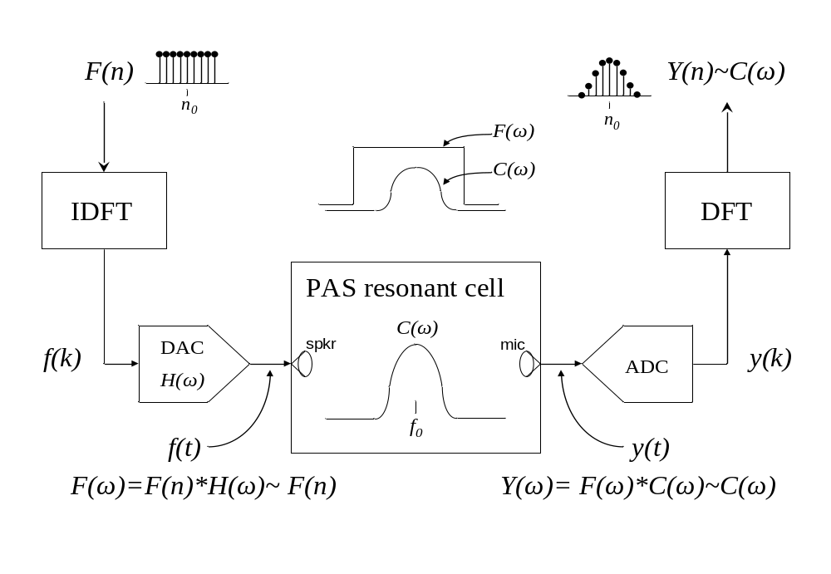
Figure 1. Technique to measure the frequency response of the PAS acoustic cell.

Synthesis method

In this method, we first build a discrete complex spectrum comprising all of the frequencies we wish to generate. A T-second signal sequence sampled at τ_{s} has N = T/τ_{s} samples. T is the dwell time. Eqs. 1 and 2 respectively show the forward and inverse discrete Fourier transforms where F(n) is the frequency domain, and f(k) is the time domain sequence, both of which are complex and periodic.

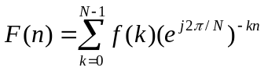 (1) 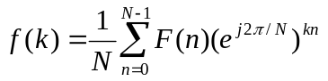 (2)

In a common interpretation, the N-point complex frequency spectrum ranges from (1-N)/2τ_{s} to N/2τ_{s} with resolution of 1/T. For example, a 1-s sequence sampled at τ_{s} = 10μs (f_{s} = 100 kSps) has an N = 100000-point spectrum from -49999 to +50000 Hz with 1 Hz resolution. The N^{th}/2 point (the Nyquist frequency) is ambiguous and may be ascribed to -50000 or +50000 Hz (or both).

Assume that the cell resonance is centered at f₀ Hz and we want the test signal to span f_{sp} Hz. We form the real part of the complex spectrum by setting R[F(n)] = 1 for values of n corresponding to f₀-f_{sp}/2 to f₀+f_{sp}/2 and zeroing the rest. The imaginary part, I[F(n)] = 0 for all n. This is shown in Fig.1 for f₀ = 1400, f_{sp} = 40, and f_{s} = 100 kSps case. Although shown as a continuous function in the upper figure, bear in mind that it only has values at discrete frequency intervals, as shown in the lower figure.
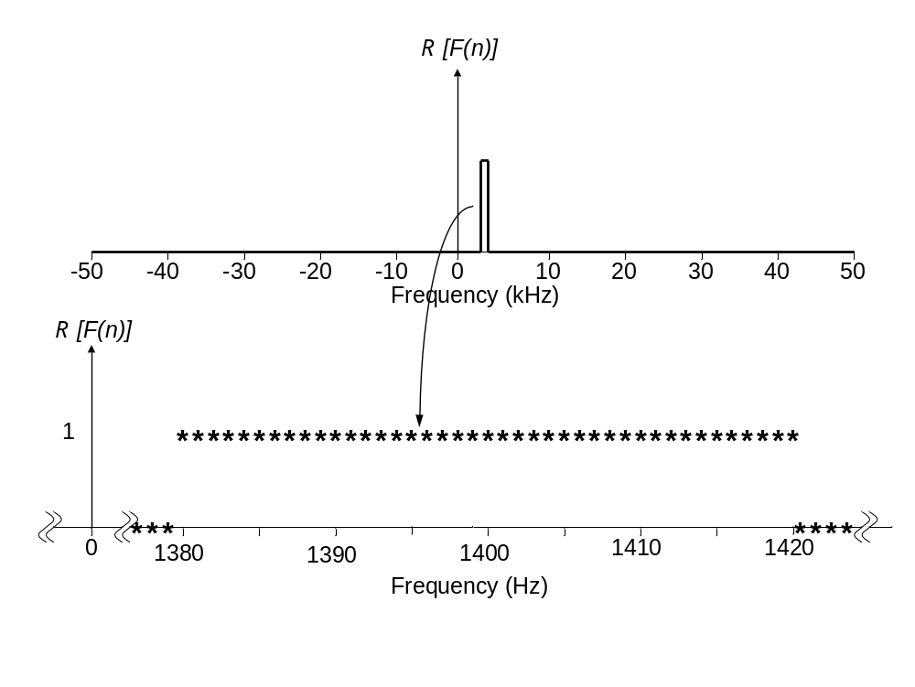
Figure2. R[F(n)] formed by setting select values of F(n) to 1. I[F(n)] is all zeros.

We then compute the inverse discrete Fourier transform using Eq. 2. The resulting discrete time sequence, f(k), is complex and its real part is shown in Fig. 3. The imaginary part of f(k) looks similar on this 1-s time scale but Fig. 4 shows that R[f(k)] is cosinusoidal and I[f(k)] is sinusoidal.
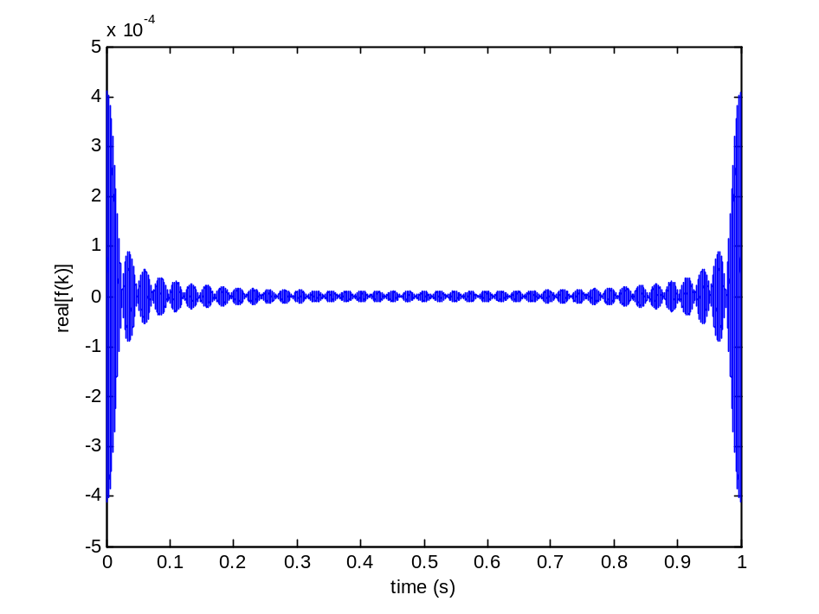
Figure 3. Real part of f(k), the inverse DFT of the spectrum of Fig. 1. The imaginary part looks similar on this time scale.
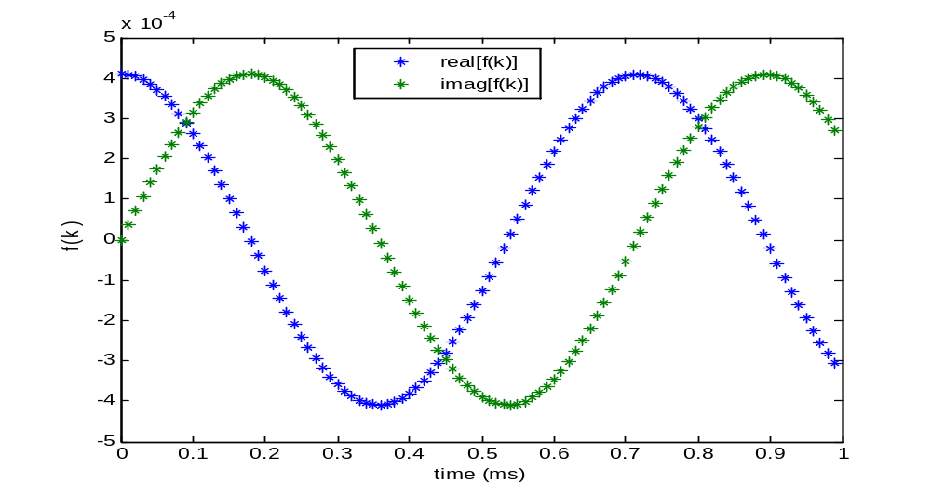
Figure 4. First millisecond of f(k). R[f(k)] is cosinusoidal. I[f(k)] is sinusoidal.

Digital to analog conversion

Either of these sequences may be used to drive the piezoelectric speaker. The sinusoidal sequence is appealing because it starts and stops at zero so there’s no abrupt jump in the speaker driving voltage.

When converted to an analog signal at the designed sampling time τ_{s}, the discrete f(k) sequence is converted to a continuous-time signal,

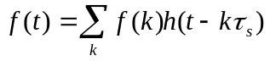, (3)
where h(t-kτ_{s}) is the impulse response of the digital to analog converter (DAC). For an ideal DAC response, sometimes referred to as a zero-order hold function, h(t-kτ_{s}) is a constant over each τ_{s} time period. Using the signals of Fig. 4 as inputs, the DAC analog output signals look like those shown in Fig. 5 over the first .5 ms.
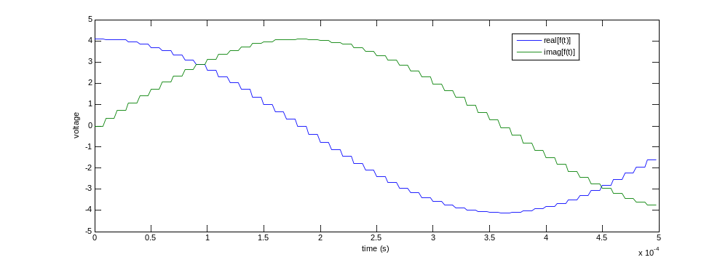
Figure 5. First 0.5 ms of DAC analog output signals for input signals shown in Fig. 4.
The frequency response of the zero-order hold circuit is 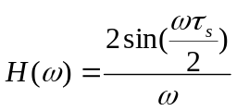, a sinc function with its first zero crossing at 100000 Hz (Fig. 6). It is essentially a constant at frequencies around 1400 Hz (Fig. 7) so the spectrum of the DAC output, F(ω) (the Fourier transform of f(t)), is a continuous spectrum that approximates the discrete spectrum of Fig. 1 quite accurately. However, any circuitry associated with the DAC or ADC (such as post-DAC reconstruction, or pre-ADC anti-aliasing filters) that has non-uniform frequency response over the frequency span of C(ω) will distort our estimate for it and may result in error the resonant frequency.
Figure 6. Frequency response of DAC, H(ω). Figure 7. H(ω) over frequency range of C(ω).
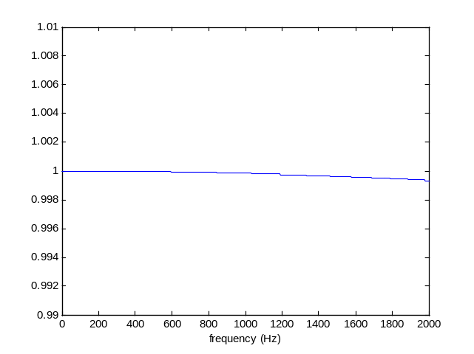
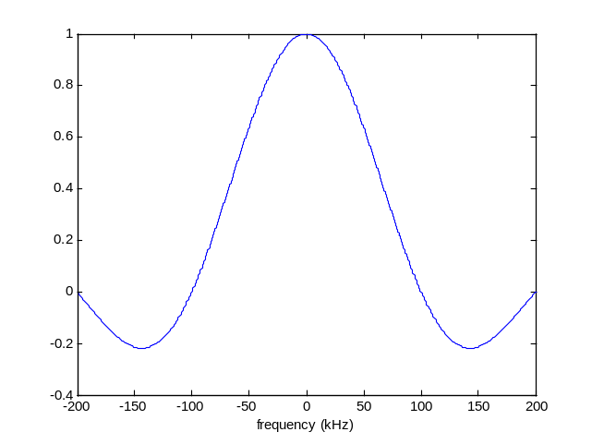
Recalling that f(k) is a periodic function, we may cycle through the sequence multiple times to generate the speaker drive signal of any duration. Fig. 7 shows 3 periods with total duration of 3 seconds. Our motivation here is to generate a speaker signal long enough to allow the acoustic cell to “ring up” its resonant state (typically a few ms) and for us to acquire the acoustic signals from the microphone for subsequent analysis.
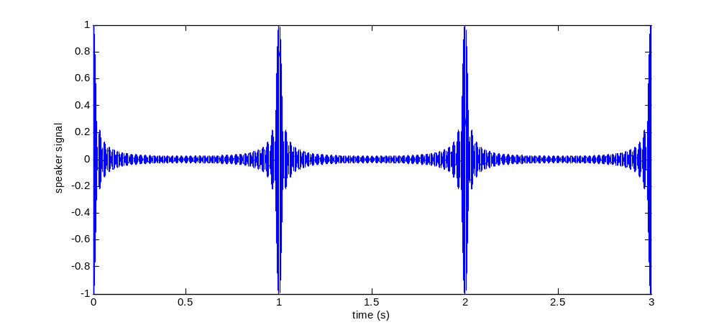
Figure 7. Three periods of speaker waveform.

Sampling

We may sample the microphone signal y(t) for T seconds and compute Y(n), the DFT of the time sequence y(k) (see Fig. 1). It is not necessary to sample the signals at the same rate as the D/A conversion of the test signal (100 kSps in the above example). However, it is important that the sampling dwell time match the dwell time used to synthesize the test signal (1 s in the above example). This insures that we sample the signal spectrum at the same frequencies generated by the test signal. Also, we need not synchronize the data acquisition to the start of the test signal period. Fourier theory tells us that a shift in the time domain transforms to a phase shift in the frequency domain. When we compute the power spectrum from the complex Y(n), we loose the phase information. Fig. 8 shows a 1-s time sequence of f(k) that does not start at the beginning of the test signal of Fig. 3. Its complex and power spectra around the resonant frequency of 1400 Hz are shown in Fig. 9. The power spectrum is the desired flat-topped window over the frequency span.

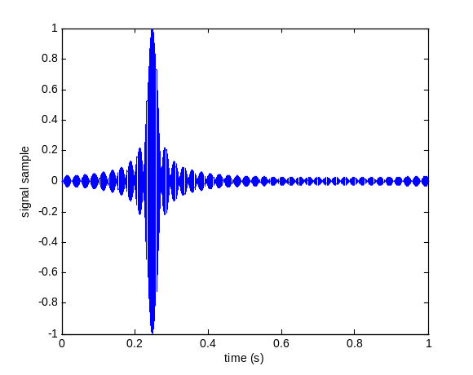
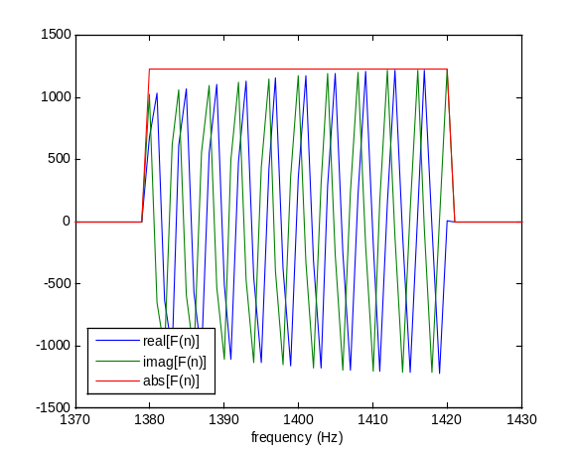
Figure 8. 1-s sample at arbitrary start time. Figure 9. Complex and power spectra.

Example case

We wish to make the measurement in about 1 second for a PAS cell with nominal resonant frequency of 1400 Hz and Q of 50.

- Choose the frequency span around f₀, of the acoustic cell. The band must be wider than the Q of the cell plus the expected change in resonant frequency due to pressure and temperature variations in the air sample. For a first approximation, use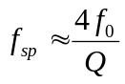. For our case, f_{sp} ~ 112 Hz. Let’s use 100 Hz.

- Choose the synthesis sampling parameters. The dwell time is a trade off between the shortest time required, and the desired frequency resolution of the measurement (Δf=1/T). For our case, T=1 s and Δf =1 Hz. Next, choose the sample rate, f_{s} = 1/τ_{s}. It must be high enough that the DAC frequency response is flat over the frequency span of the cell (see Figs. 6 and 7). A good minimum sampling rate is 25(f₀) ~ 35 kSps for our case. Let’s use f_{s} = 50 kSps (τ_{s} = 20 μs). This results in N=50000 points in our spectrum and time sequences.

- Since Δf=1 Hz for our case, it is simple to design the signal spectrum. n = 0 to N/2 in (2) corresponds to f = 0 to 25 kHz. We simply set R[F(n)] = 1 for 1350 ≤ n ≤ 1450 and 0 elsewhere. I[F(n)] = 0 for all n.

- Compute the inverse FFT using Eq. 1. We then use either the real (cosine) or imaginary (sine) part of the resulting 50000-point complex sequence f(k), which looks similar to those shown in Figs. 3 and 4. Let’s reorder the sequence so that the peak of the “chirp” signal is in the middle of our output waveform duration. We also append (from the appropriate part of our periodic f(k)) about 10 ms on the front and the back of the waveform to allow the cell to ring up and ring down. The resulting waveform (normalized to 1 volt) is shown in Fig. 10.
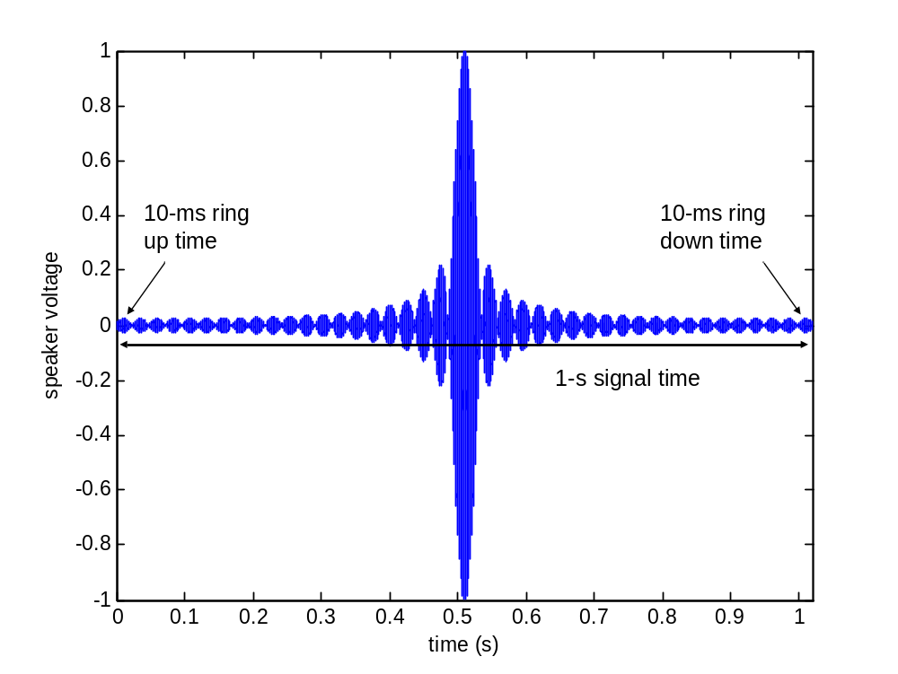
Figure 10. Speaker waveform, 1.02-second duration.

- We next sample the microphone signal as shown in Fig.1. The sampling rate is not critical as long as it’s well above the nyquist criterion for the signal of interest. For simplicity, let’s sample at the same rate used to generate the speaker signal, 50 kSps. This is well above the nyquist frequency of about 3 kHz for our 1400-Hz resonator. We should wait for 10 ms after the speaker signal is applied before digitizing the microphone signal. This allows for the cell to ring up and achieve resonance. We then sample for exactly 1 second. The sampling dwell time is critical if we are to match the frequencies that we generated in step 2 above.

- The 50000 points collected in step 5 are used as the real input to the DFT shown in Fig. 1. We form the power spectrum by multiplying each of the complex values of Y(n) by their complex conjugate. The resulting power spectrum may then be fitted with a nonlinear function, the peak of which determines the resonant frequency. The resonator Q may be estimated by calculation the half-power point of the power spectrum.

